TrendeeVerse
COLLECTIONS

SIZE CHART
Butterfly Avant Garde Dress With Tulle And Silk Splitted Tail , Handmade Embroidery Laser Cut , With Swarovski Crystals

SKU : TV00154FDES

Please type your details , then print or save and send to: director@fte.ae

NAME: ___________________________________________________
PHONE NUMBER: __________________________________________
Email: ____________________________________________________

BODY PART TO BE MEASURED |  |  | DESCRIPTION / GUIDE |  | YOUR MEASUREMENT |  | ADDITIONAL REMARKS
Shoulder |  |  | Refer to No. 1 in Measurement chart
Off Shoulder |  |  | Refer to No. 2 in Measurement chart
Neckline Front Deep |  |  | Refer to No. 10 in Measurement chart
Neckline Back Deep |  |  | Refer to No. 9 in Measurement chart
Carrure Front |  |  | Refer to No. 11 in Measurement chart
Carrure Back |  |  | Refer to No. 12 in Measurement chart
Breast Point |  |  | Refer to No. 13 in Measurement chart
Breast Distance |  |  | Refer to No. 14 in Measurement chart
Breast Down Empire |  |  | Refer to No. 15 in Measurement chart
Empire Round |  |  | Refer to No. 16 in Measurement chart
Upper Breast /Chest |  |  | Refer to No. 17 in Measurement chart
Breast |  |  | Refer to No. 18 in Measurement chart
Waistline |  |  | Refer to No. 19 in Measurement chart
Figure Front |  |  | Refer to No. 20 in Measurement chart
Figure Back |  |  | Refer to No. 21 in Measurement chart
Skirt Length |  |  | Refer to No. 24 in Measurement chart
Full Length |  |  | Refer to No. 25 in Measurement chart
 | MEASUREMENT CHART
 |  | BODY PART TO BE MEASURED |  | IMAGE |  | DESCRIPTION
 | 1. | Shoulder  (Front) |  | 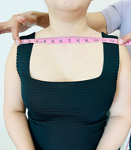 |  | Measure straight from the edge of the left shoulder across to the edge of the right as shown in the photo
 |  | Shoulder (Back) |  | 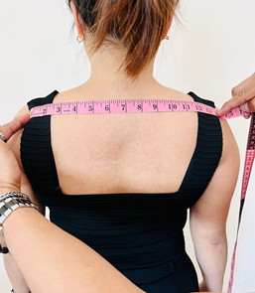 |  | Measure straight from the edge of the left shoulder across to the edge of the right
 | 2. | Off Shoulder |  | 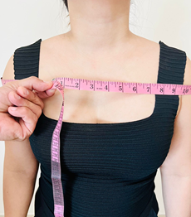  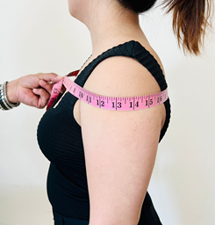 |  | Measure from the edge of one shoulder then wrap around the chest and back to the same shoulder, 360 degrees. Ensure the right fit as this is the off shoulder measurement
 | 3. | Short Sleeves |  | 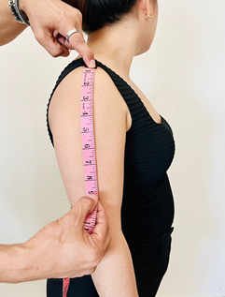 |  | Measure from the edge of the shoulder up to the length of the sleeves ex. ¾ sleeves , full arm sleeves
 | 4. | ¼ Sleeves
 | 5. | Full Sleeves
 | 6. | Arm Hole |  |  |  | Wrap the measuring tape measure tape around the armpit or axilla across the outside edge of shoulder. As shown in the photo
 | 7. | Muscle 5 |  |  |  | Stand up straight with one arm relaxed, and find the midpoint between the shoulder bone and the elbow of that arm. Wrap the measuring tape around the arm (biceps)
 | 8. | Cuffs |  | 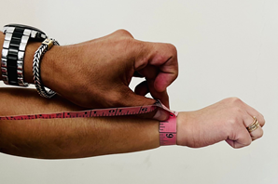 |  | Wrap the measuring tape around your wrist
 | 9. | Neckline Back width  “back neck depth measurement |  |  |  | Measure from the joint where the neck and shoulder meet , going down to how deep your back neckline would be
 | 10. | Neckline front deep  V Neckline |  | 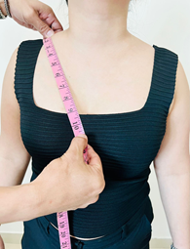 |  | Place the measuring tape around the neck at the height where the collar would normally rest, up to how deep is the V neckline
 | 11. | Carrure Front |  | 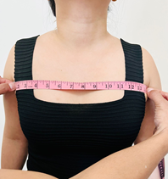 |  | Face front, measure from the upper fold of the right armpit across the chest to the left upper fold of the left armpit
 | 12. | Carrure Back |  | 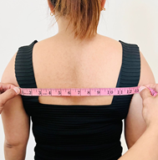 |  | Back side , measure from the upper fold of the right armpit across the chest to the left upper fold of the left armpit
 | 13. | Breast Point |  | 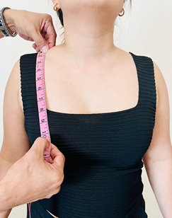 |  | Measure from mid shoulder to top of nipple
 | 14. | Breast Distance |  | 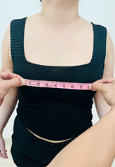 |  | Measure from top of nipple A to nipple B, nipple to nipple
 | 15. | Breast Down Empire |  | 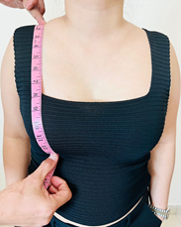  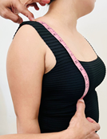 |  | Measure from middle of the shoulder to under the breast including the breast form
 | 16. | Empire Round |  | 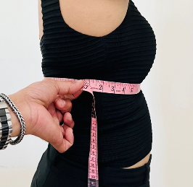 |  | Measure the entire chest 360 degrees under the breast. Measure from the middle of the chest under the breast, and around the chest and back to the starting point
 | 17. | Upper Breast /Chest |  | 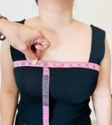 |  | Measure the entire chest 360 degrees on top of the breast. Measure from the middle of the chest on top of the breast and around the chest and back to the starting point
 | 18. | Breast |  | 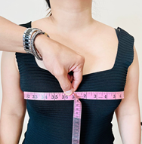 |  | Measure from nipple line then around chest , 360 degrees around the body , then
 | 19. | Waistline |  |  |  | Measure the full waistline around the body
 | 20. | Figure Front |  |  |  | Measure from middle of the shoulder to the waistline while facing front
 | 21. | Figure Back |  | 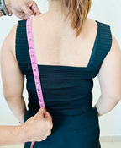 |  | Measure from middle of the shoulder to the waistline while on the backside
 | 22. | First Hip |  | 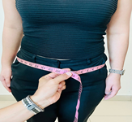 |  | Measure around the upper hips
 | 23. | Second Hip |  | 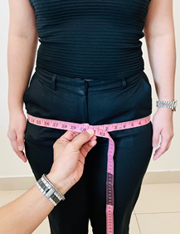  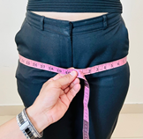 |  | Measure around the lower hips middle buttocks area , 360 degrees
 | 24. | Skirt Length |  | 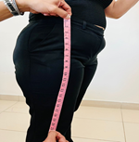 |  | Measure from the waistline then down to the length of the skirt
 | 25. | Full Length |  | 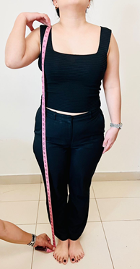 |  | Measure from the shoulder to the floor

